

**Lab no.: 1 Date: February 11, 2024**

**Write a recursive program to find the Factorial of given input.**

In Mathematics, factorial is an important function, which is used to find how many ways things can be arranged or the ordered set of numbers. The well-known interpolating function of the factorial function was discovered by Daniel Bernoulli. The factorial concept is used in many mathematical concepts such as probability, permutations and combinations, sequences and series, etc. In short, a factorial is a function that multiplies a number by every number below it tills 1. For example, the factorial of 3 represents the multiplication of numbers 3, 2, 1, i.e., 3! = 3 × 2 × 1 and is equal to 6.

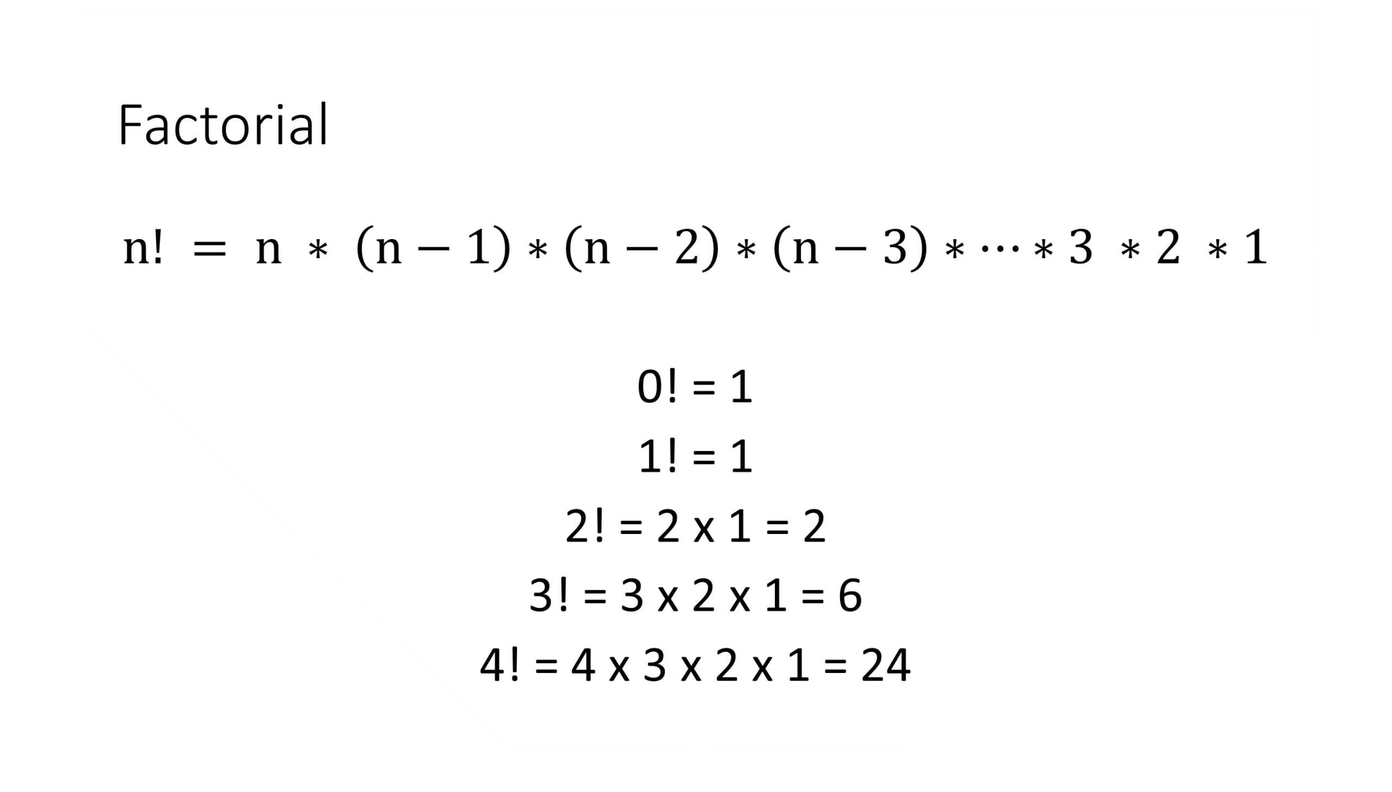

Figure 1: Factorial

**Programming Language: C**

**IDE: Microsoft Visual Code**

**Source code:**

#include <stdio.h>

int facto(int n)

{

static int fact=1;

if (n == 0 || n == 1)

return fact;

else

fact = n * facto(n - 1);

}

int main()

{

int n;

printf("\n.....FACTORIAL.....\n");

printf("Enter an integer: ");

scanf("%d", &n);

int res = facto(n);

printf("\nThe factorial of %d is: %d ", n, res);

return 0;

}

**Outputs:**

